Asian countries can be divided into 4 categories.
- Countries of the Far East-China, Korea, Japan, Vietnam, and others.
- Countries of the Middle East-Armenia, Iran, The Maldives, Afghanistan, Pakistan, India, and others.
- Countries of the Near East-Iraq, Yemen, Jordan, Syria, Lebanon, and others.
- Countries of the Persian Gulf-Bahrain, Kuwait, Saudi Arabia, the United Arabic Emirates, Qatar, and Oman.

- Fill in the sentences.

Here, we will be dealing with countries of the Near East which we can also call …………. Most of the population speaks…………and are………………. Islam, following Christianity, is the second………. world religion.
Arabian
Arabic
Muslims
Largest

So ends the reign of the days of fasting,
One month, I’m completely weak,
Joyfully heralding, that the ramadan is ending,
And with my mouth wide open as if out of starvation
A starry Pleiad chasing across the sky
(The Desert poets, Arabian poetry of 9 centuries)

This Arabian poem talks about a traditional Muslim custom, that every Muslim must complete once a year.
- Read the poem carefully and try to write down which tradition/commandment it is talking about.

……………….

- Would you be able to explain how this tradition relates to the words fasting and starvation, which are marked in bold letters?

Traditions and art from the orient also made its way to Europe and America, we can see it in Music for example.
- Melodic rhythms are unique, impressive, and calming.

- Write down one typical trait for Arabic music.

- What do you like/dislike about this music?

- Have you ever heard this kind of music in an oriental restaurant or in another establishment you have visited in your home country or somewhere else in Europe?
- Are any of these melodies similar to any music you know?

https://www.youtube.com/watch?v=3R1eUfVxOGI
https://www.youtube.com/watch?v=oV8T5qX7rnk

- Fill in the sentences.

In Arabian culture, the role of the whole family is important. In raising children they emphasize …………, …………., ………..
Some women who follow Islam walk around ……….
A Muslim can have up to 4 ………., But nowadays they usually have one wife.

Respect towards parents
Concealed
Faith in God
Regard for traditions
Wives
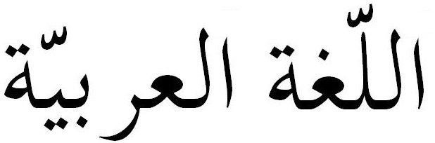
- What is the difference when writing in Arabic?

- Try to write your first name and surname from the right side to the left.

……………………………………………………………………….

The numerals are also different from what we have.

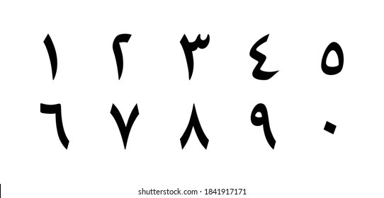

In the end we will look at Mecca. The Holy City of Islam.

- Where is Mecca located? Use the atlas.

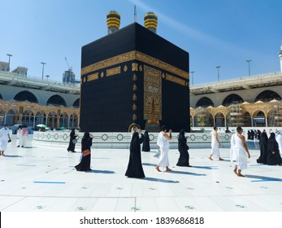
- Every Muslim must visit Mecca at least once in their life. Could you explain why they specifically visit the city Mecca?

